**Project - Phase II: Decision Making**

**Student Name:** Ashish Bhaskar Bandarkar

**Section:** - IFT 598 Data Visualization & Reporting for IT

**Section:** 2023Spring-P-IFT598-29280

**Instructor Name**: Prof. Asmaa Elbadrawy

**Due Date**: 16th April 2023

### 

### 

### 

### 

### Choosing Visualization Tools

Tableau was chosen for this project because it features a user-friendly interface and tools that allow users to organize and see data that is relevant to their queries. We picked tableau over Python Bokeh since it requires code to show any plots, which is time intensive, and because we are building a dashboard, the amount of code required will be significant and difficult to manage in such a short amount of time.Our dataset doesn't require any preparation, which Tableau can handle quickly, thus it's a good fit for the job. However, if the dataset was high-dimensional, Python Bokeh or a similar programming-based tool could have been preferable.

### Data Preparation & Preprocessing

We just need to preprocess two columns in our dataset: date and time.The date format is mm/dd/yyyy, but we need month and days to be separate to do visualization, and the time format is in hours and minutes from which we just need hours to visualize, thus we'll use tableau to preprocess data because it can handle it using the split function.

### List of the Final Set of Questions

1. What is the frequency of payment methods for invoice attributes?
2. What would be the total sales of a branch per month?
3. What would be the total sales of a product line per month?
4. Checking the number of visitors for each customer type.
5. What is the average rating for a product line per city?(reference line and true false)
6. How much were the total sales per day across each month?
7. Gender Wise distribution of the number of visitors that are members in a specific city.
8. What is the gross profit made per product line in each branch?
9. What is the frequency of Gender purchasing over all the product lines?
10. What would be the average quantity sale for all Product lines?(Add month filter)
11. What is the average rating for a product line per month by a particular gender?
12. What’s an average sale made in a specific time period with respect to the branch?

### List of Plots

1. **What is the frequency of payment methods for invoice attributes?**

**Plot 1: Bar chart**

This plot shows the number of customers using a particular payment method. There are three types of methods called cash, credit card or ewallet. Therefore, the dashboard users will be able to figure out which method customers use the most.

**Pre-attentive attributes:**

· Length

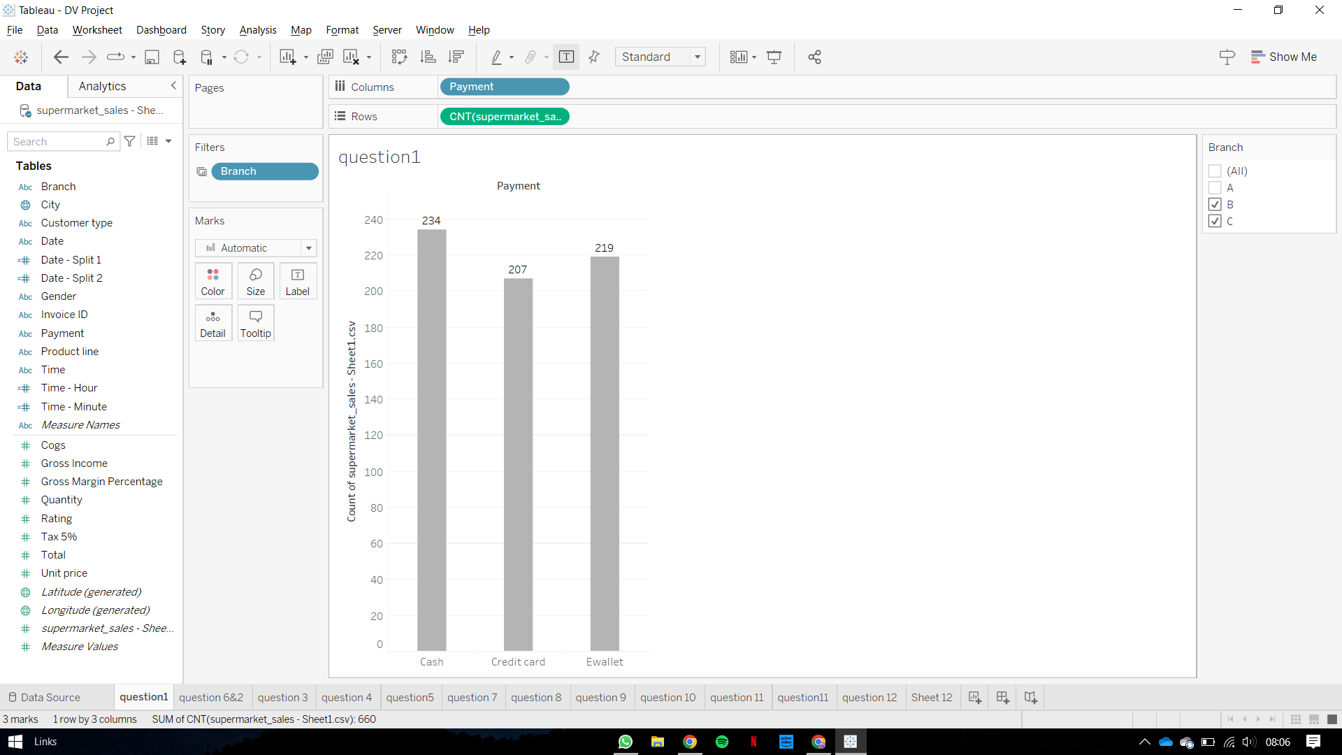

1. **What would be the total sales of a branch per month and How much were the total sales per day across each month?**

**6.How much were the total sales per day across each month?**

**Plot 2 & 6: Line Plot**

This plot shows the number of sales done for any particular day in a month. It has a filter to select a particular month to see the distribution. Therefore, the dashboard users will be able to figure out the date on which the highest amount of sales is done for any month.

**Pre-attentive attributes:**

· 2-D Position

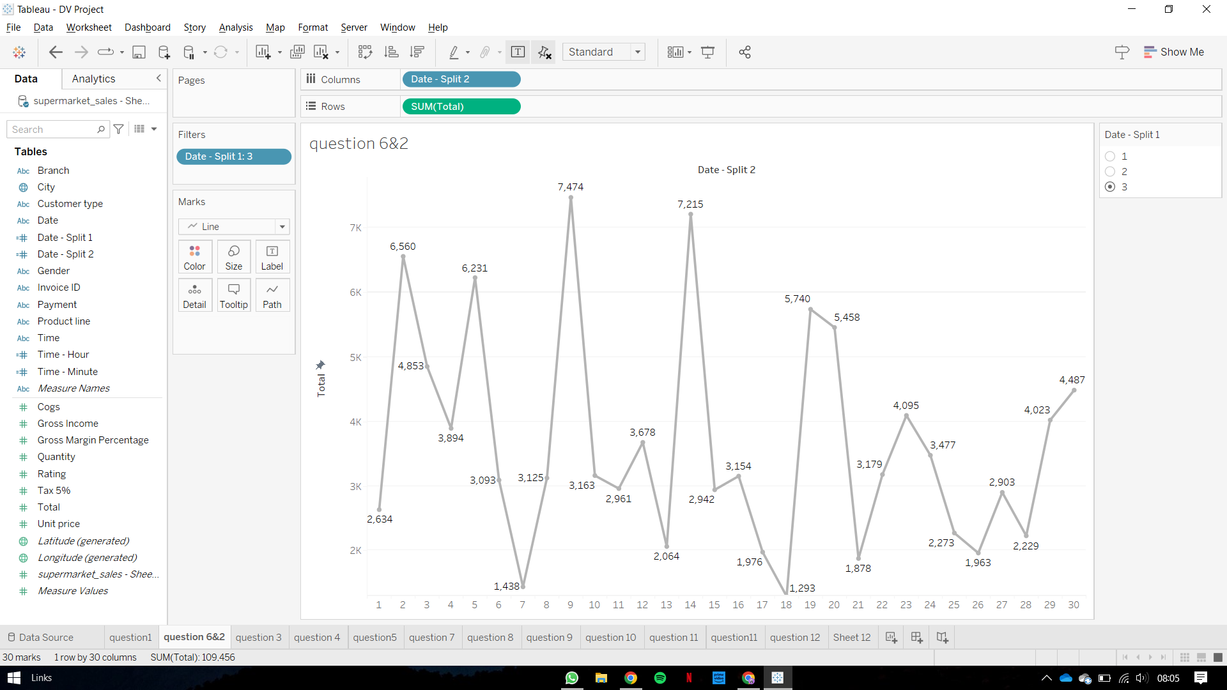

1. **What would be the total sales of a product line per month?**

**Plot 3 & 11: Line Plot**

This plot shows the number of sales done for all the product lines per month. It has a filter to select a particular month to see the distribution. Therefore, the dashboard users will be able to figure out the total sales of any particular product for any month.

**Pre-attentive attributes:**

· 2-D Position

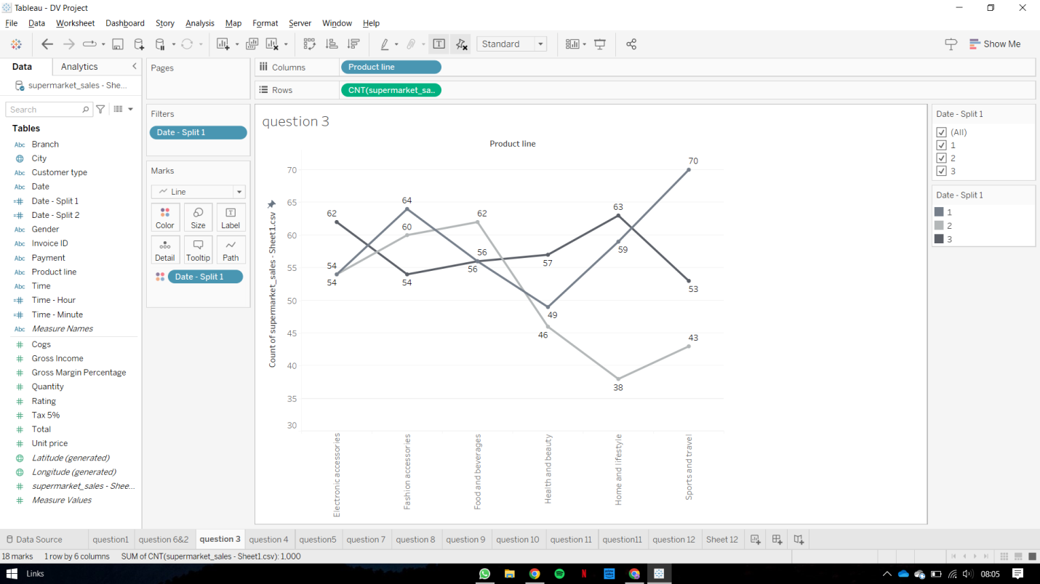

1. **Checking the number of visitors for each customer type?**

**Plot 4: Bar chart**

This plot shows the number of members from the total visitors. It has a filter to select a particular branch to see the distribution. Therefore, the dashboard users will be able to figure out the number of people taking membership at the store.

**Pre-attentive attributes:**

· Length

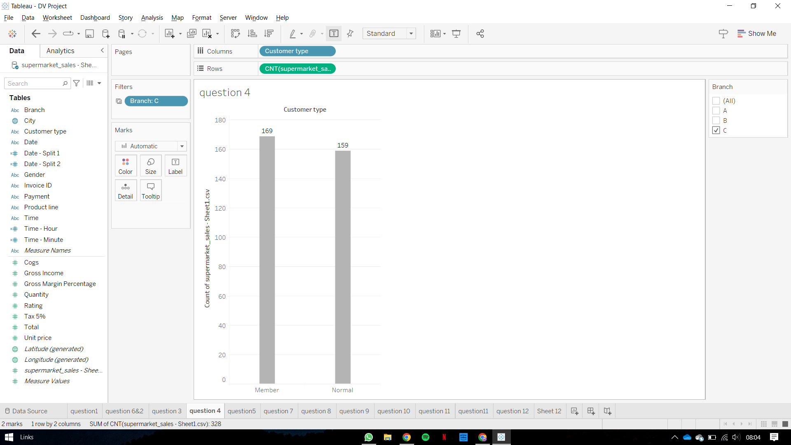

1. **What is the average rating for a product line per city?**

**Plot 5: Line Plot**

This plot shows the average rating for each product line. It has a filter to select a particular branch and a particular month to see the distribution. Therefore, the dashboard users will be able to figure out the average and minimum rating for every product line at the store.

**Pre-attentive attributes:**

· 2-D Position

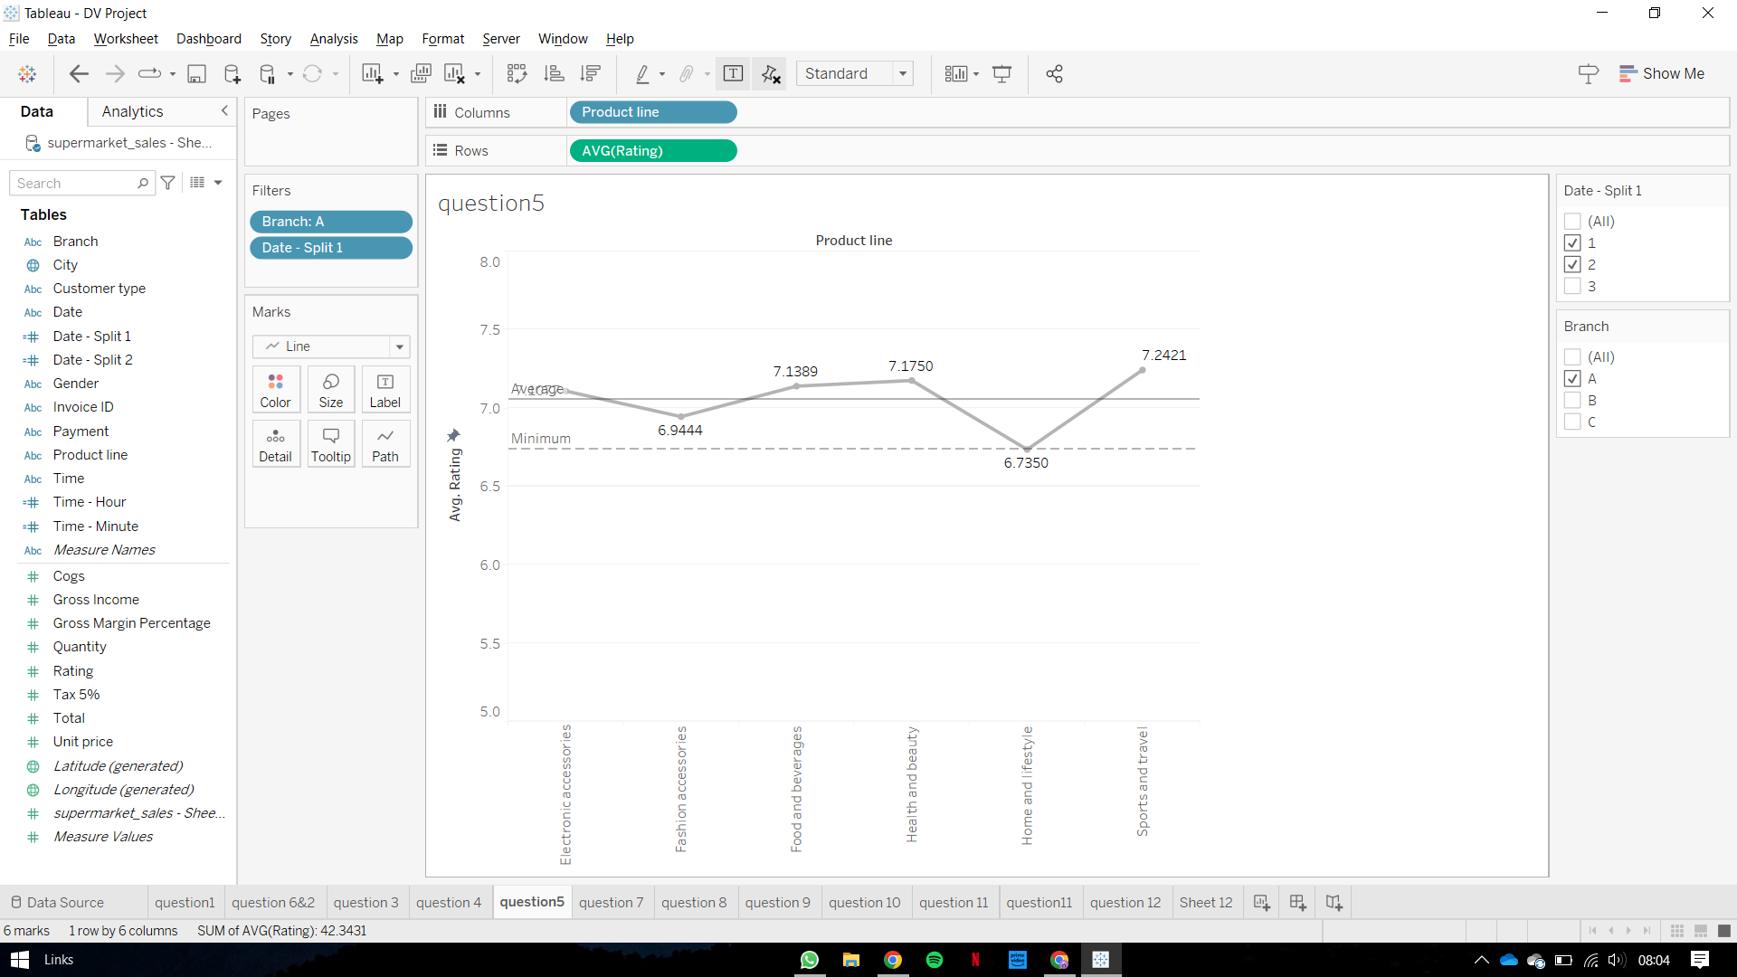

**7. Gender Wise distribution of the number of visitors that are members in a specific city.**

**Plot 7: Stacked Bar Plot**

A stacked bar chart with gender on the x-axis, the number of visitors on the y-axis, and a filter for cities could represent the gender-wise distribution of visitors to a specific city. This type of visualization can help identify any gender-based differences in visitor patterns across cities. For example, if one city has significantly more male visitors than female visitors, this might suggest that the city's attractions or marketing efforts are more appealing to men. Conversely, if another city has a more even gender distribution among visitors, this might suggest that its attractions or marketing efforts are more appealing to a broader audience.

**Pre-attentive attributes:**

· Length

· Color Hue

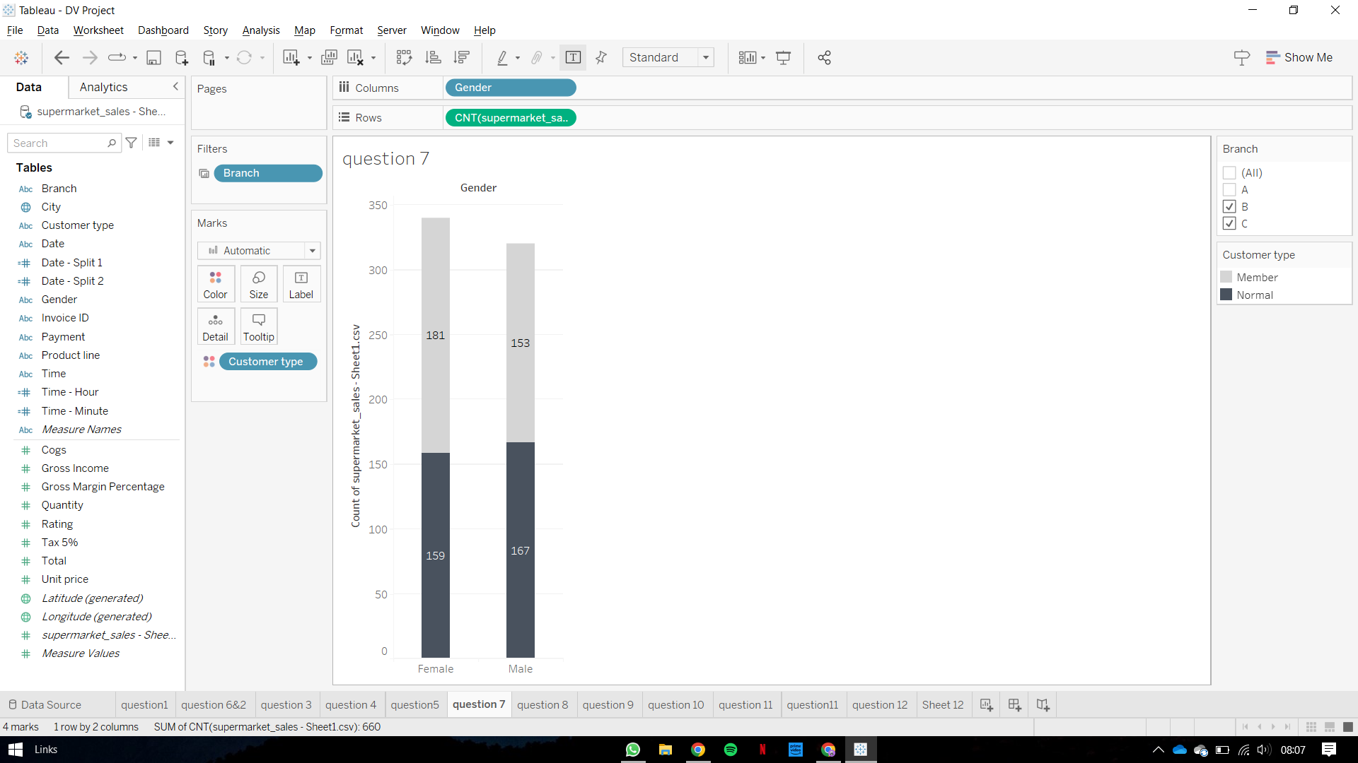

**8. What is the gross profit made per product line in each branch?**

**Plot 8: Bar chart**

Each bar in the chart would reflect the overall gross income for a single product line, with the bar height denoting the amount of gross income and the filter allowing users to view the gross income for each product line in different branches. This visualization can be beneficial for finding the most profitable product lines in the company's various branches, as well as for making investment and development decisions.

**Pre-attentive attributes:**

· Length

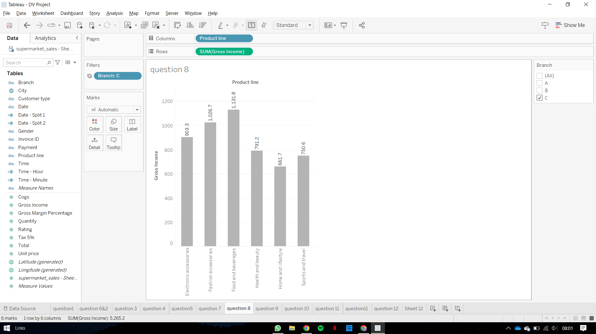

**9. What is the frequency of Gender purchasing over all the product lines?**

**Plot 9: Stacked Bar Plot**

The visualization can help to evaluate the performance of different product lines across multiple branches and identify which products are more popular among visitors in each branch by utilizing the branch filter. Furthermore, the stacked bar chart can display the proportion of male and female visitors in each product line, providing insight into the preferences of various client segments. Overall, this visualization can help organizations adjust their product offers and marketing methods to attract and keep customers.

**Pre-attentive attributes:**

· Length

· Color Hue

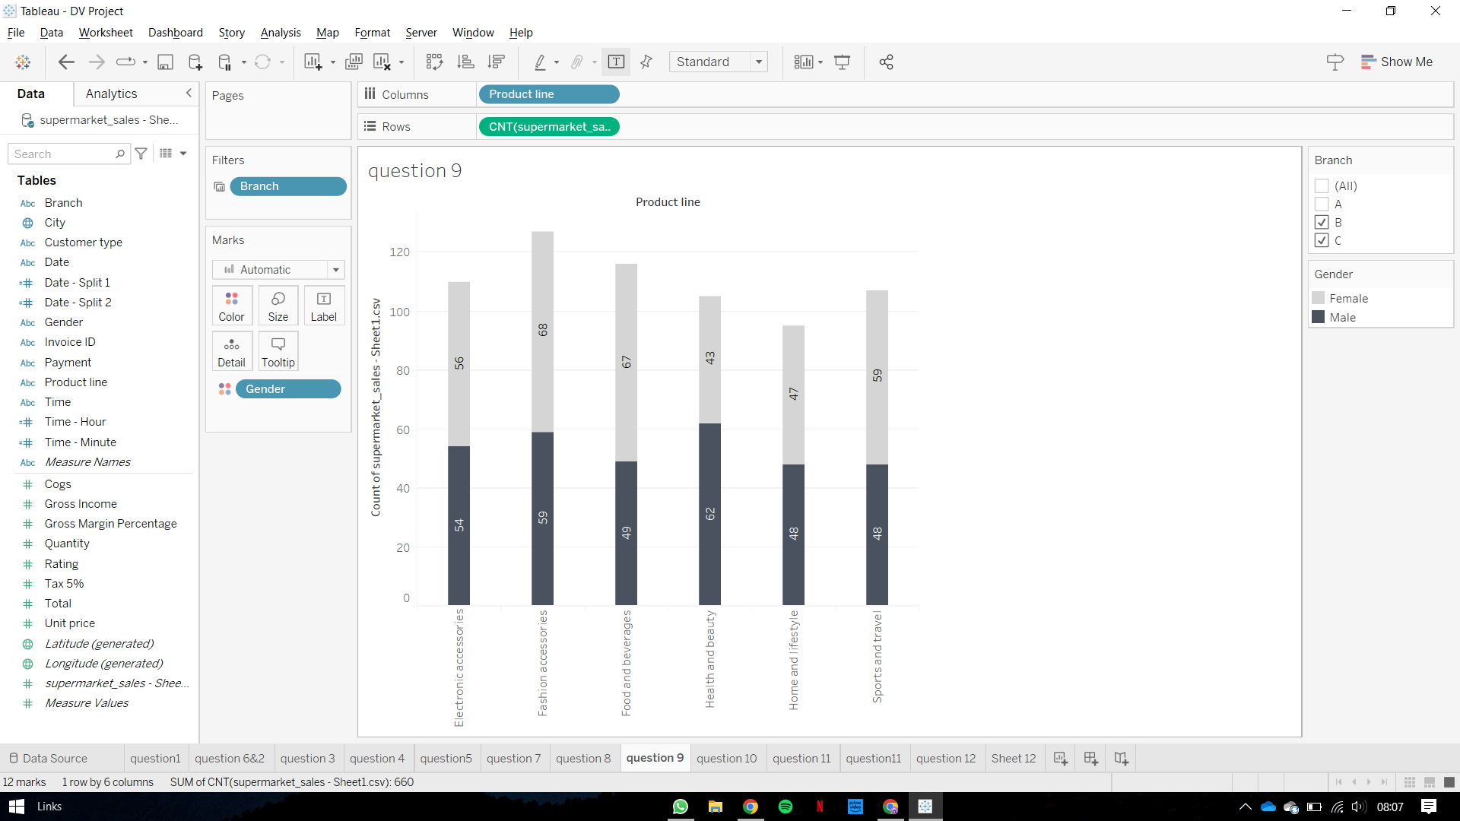

**10. What would be the average quantity sale for all Product lines?**

**Plot 10: Bar chart**

The filter for different branches and months allows the reader to interact with the chart and investigate how product sales change across different places and time periods. By changing the filter choices, the user may see how sales change across branches and months for each product line. Overall, this representation allows for immediate comparison and understanding of how product sales differ across various product lines, as well as more extensive investigation of sales trends across multiple regions and time periods.

**Pre-attentive attributes:**

· Length

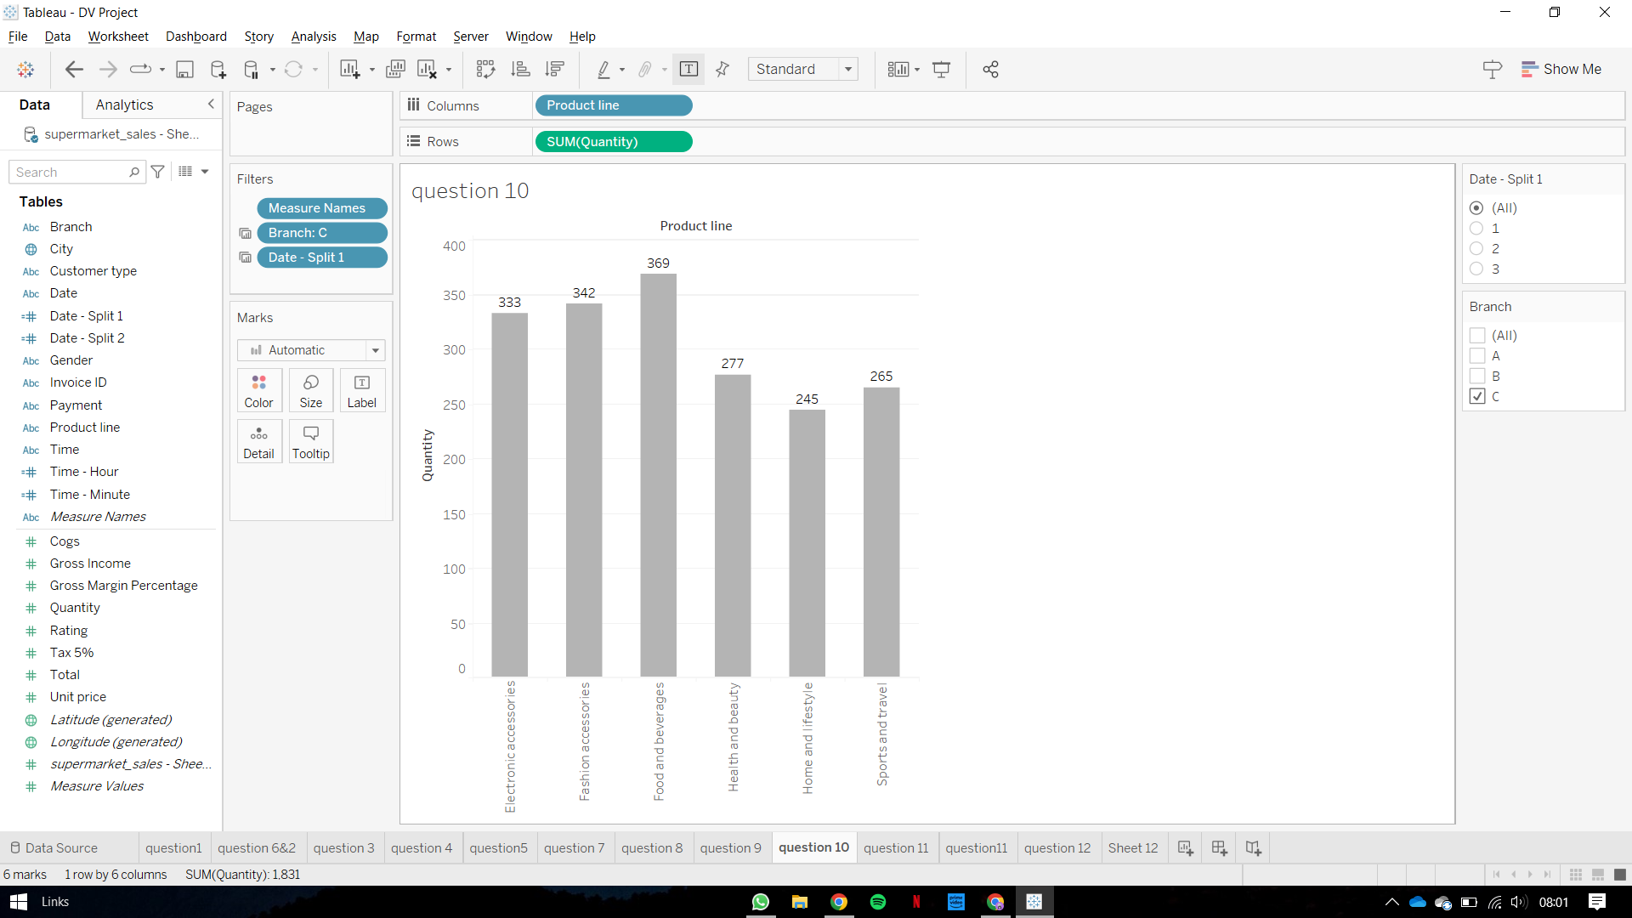

**11. What is the average rating for a product line per month by a particular gender?**

**Plot 11: Line Plot**

The graph would show how the average ratings given by male and female consumers have changed over time. It would also assist in determining whether there are any notable disparities in the ratings given by male and female clients for various product lines. This visualization may be useful in recognizing patterns and trends in customer preferences as well as making data-driven decisions about product development, marketing, and sales tactics.

**Pre-attentive attributes:**

· 2-D Position

· Color Hue

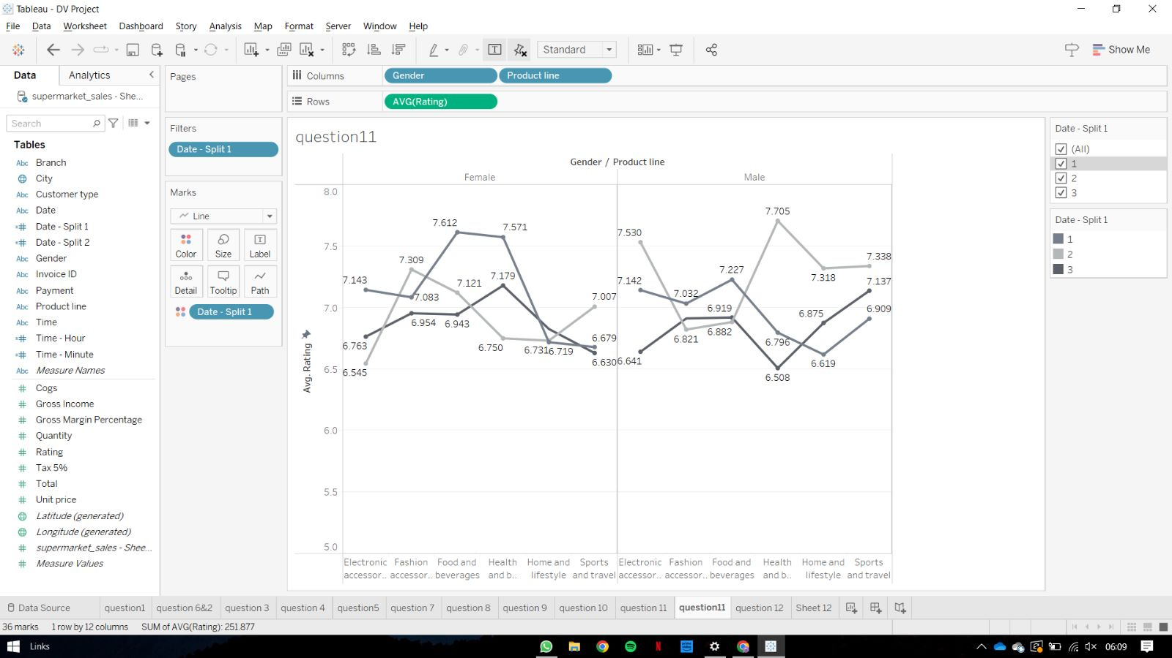

**12. What’s an average sale made in a specific time period with respect to the branch?**

**Plot 12: Line Plot**

The chart's line depicts the pattern in the number of invoices over time, with peaks and troughs reflecting times of greater and lesser activity. The branch filter lets you choose an individual branch or group of branches to view their billing activity independently. This can aid in identifying any discrepancies or similarities in the trend of invoice activity between branches. Overall, this line chart gives useful information on the hourly patterns of invoice generation, allowing businesses to recognize busy and slow periods and alter their operations accordingly. The branch filter offers an additional layer of analysis, allowing for a more granular view of invoice activity within each branch.

**Pre-attentive attributes:**

· 2-D Position

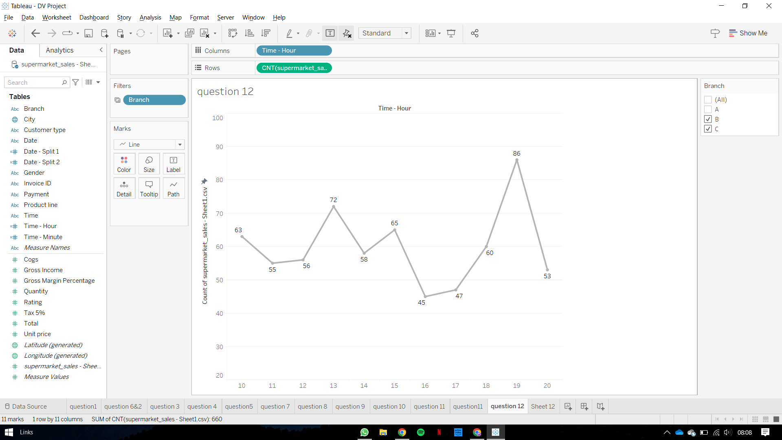

### **List of Interactive Controls**

**Branch Filter:**

Implemented in plot 1, 4, 5, 7, 8, 9, 10, 12.

A branch filter in a supermarket dataset is a useful tool for examining sales data for individual branches or locations of a supermarket chain. A user can isolate and examine sales data for a specific branch or collection of branches using the branch filter. This can assist in determining which products are popular in a certain branch and adjusting marketing or inventory strategies accordingly. Furthermore, analyzing sales data from different branches can assist the user in identifying patterns and trends that may optimize operations and increase overall sales performance. Users may make educated decisions about their operations and uncover chances for development and improvement by filtering the information to reveal only sales data for a certain branch or collection of branches. Overall, the branch filter is a valuable tool for analyzing sales data in a supermarket dataset and enhancing the operation of a supermarket chain.

**Month Filter:**

Implemented in plot 2, 3, 5, 6, 10, 11.

A supermarket dataset's month filter is a handy tool for examining sales data over time. It allows a user to isolate and examine sales data for a given time period, such as a specific month or collection of months. Users can spot trends and patterns in sales data by comparing months. This allows them to streamline processes and increase overall sales performance. Furthermore, employing the month filter can assist in tracking the efficiency of marketing or promotional activities over time, as well as identifying seasonal sales trends.In conclusion, the month filter will help the process of making rational choices about supermarket operations and recognizing chances for development and improvement. It is a strong tool for examining sales data and upgrading the operation of a supermarket chain. Using a month-by-month filter will offer significant insights into how items perform over the course of time, enabling administrators to make data-based choices about marketing and stocking strategies.

**Mural link:**<https://app.mural.co/t/mili4400/m/mili4400/1680789780520/bbef0b79bab3d701c5952e8657876f31829f090d?sender=ueae0fdde06df7d3aeafc9985>

**Color for individuals in Mural:**

Purple: Mili   
Brown: Ashish

Yellow: Monish  
Green : Everyone’s contributions